Student name: Jordan Elkin
Student ID: 226621873

SIT225: Data Capture Technologies

Activity 3.1: Arduino IoT Cloud and Dashboard with Arduino Nano 33 IoT devices

Arduino Cloud is your next exciting journey to build, control and monitor your connected projects. You can connect anything to Arduino Cloud including a wide range of compatible Arduino boards such as Arduino Nano 33 IoT or a third-party device that speaks Python. Arduino Cloud is an all-in-one IoT solution that empowers makers to create from anywhere, control their devices with stunning dashboards.

In this activity, you will connect your Arduino board to the cloud as a device, register a thing (in terms of a cloud variable) with your device, create a dashboard with a graphical widget which show value that is sent from the sketch running in your Arduino board.

Hardware Required
- Arduino Nano 33 IoT Board
- Wi-Fi hotspot (preferably your smartphone hotspot)
- USB cable

Software Required
Arduino programming environment (Arduino IDE)
Arduino IoT Cloud (https://app.arduino.cc)

Steps
Step | Action
1 | Account creation:  Create an account in Arduino IoT Cloud (https://app.arduino.cc ). Once done, login to your account.  You can follow Arduino tutorial (https://support.arduino.cc/hc/en-us/articles/360016495559-Add-and-connect-a-device-to-Arduino-Cloud ) for detail. This tutorial is referred to in the steps below.
2 | Add the device:  Follow step 1 in the tutorial to add your Arduino Nano 33 IoT device.
3 | Create and configure a Thing:  Follow step 2 in the tutorial to create a Thing (sensor) and attach it to the device created in step 2 above. Note that a Thing is created as a cloud variable of specific data types. In your sketch, there should exist the same variable name and type.  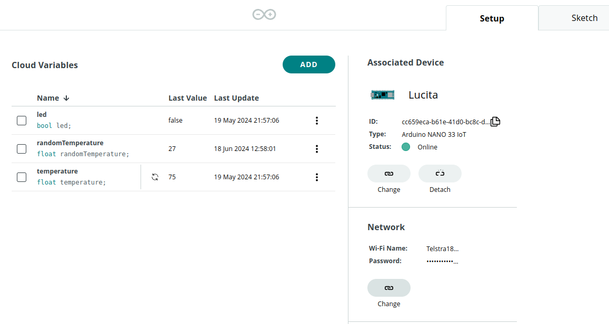  Consider only a single cloud variable ‘randomTemperature’ for this activity and ignore the rest (led or temperature).  To keep things simple, the “Sketch” tab in the above screenshot prepares
4 | Configure your Wi-Fi:  In the above screenshot, the right column shows Associated Device and Network sections. You can see “Telstra” network is shown at the time this document was prepared. This should be your smartphone hotspot which is the most convenient considering the mobility – you can carry your laptop and projects without changing in the sketch.
5 | Sketch tab:  There is a Sketch tab at the top right corner of the screenshot above which gives you code ready to deploy in your Arduino board.  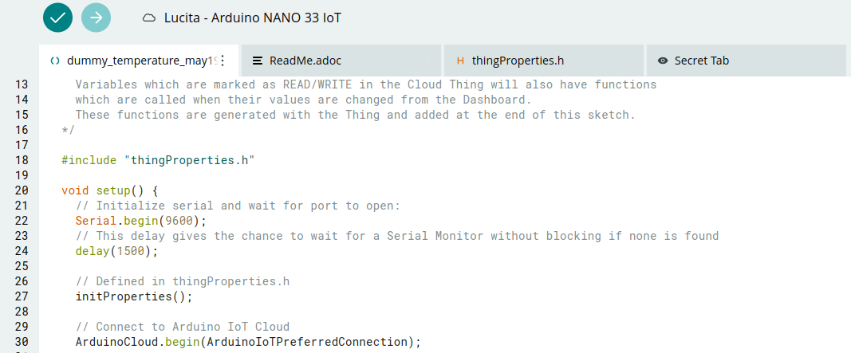  There are 3 files in the project. The first tab shows the sketch (.ino) is generally the project name. Two other sketches are header files (.h) - thingProperties.h and arduino_secrets.h.  The thingProperties.h header looks like below.  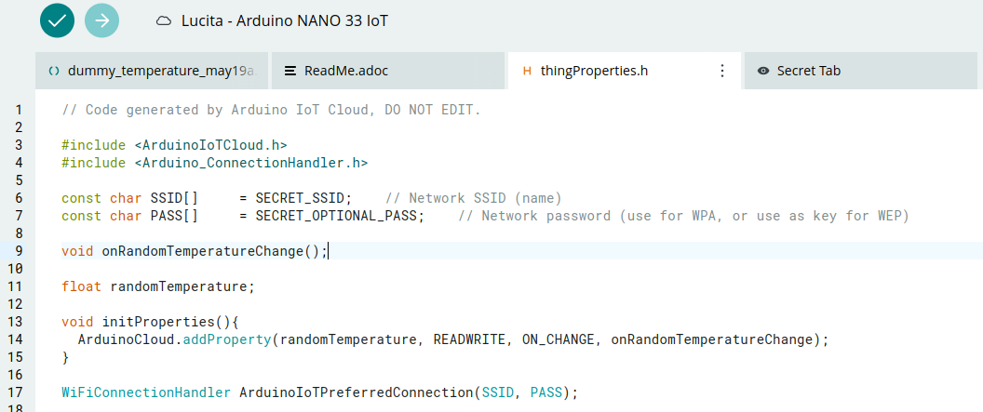  It shows several items including -  - Your wifi variables (such as ssid and password which you define in arduino_secrets.h header).  - The cloud variable exactly with the same name and type you have created while creating your Thing in step 3 above.  - An initialisation function called void initProperties() {...} which registers the Thing variable to the cloud.  - A template function ArduinoIoTPreferredConnection(SSID, PASS) which works behind the scenes to connect to the Arduino Cloud using the Wi-Fi you have configured.  The arduino_secrets.h header file contins Wi-Fi ssid and password. The Secret Tab shows fields where you can input Wi-Fi information. If you want to deploy using Cloud IDE shown above (called OTA upload), it needs to upgrade your account. Instead, you can copy the sketch to your Arduino IDE installed on your computer.  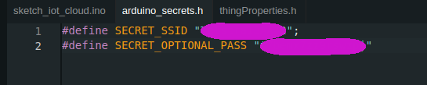  You can prepare the sketch and 2 header files as mentioned. Alternatively, you can download the code from here (https://github.com/deakin-deep-dreamer/sit225/tree/main/week_3 ).  The sketch in the GitHub link above shows the sketch below (sketch_iot_cloud.ino).  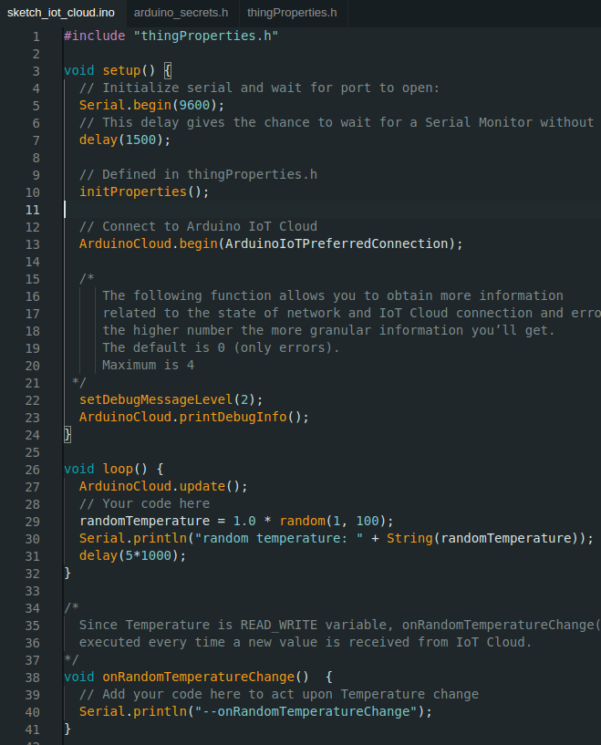  The loop function generates a random value between 1 and 100 and assigns to randomTemperature variable which is a cloud variable and write in serial port and waits for 5 seconds.  Additional library to install: Arduino_CloudUtils  More info: https://forum.arduino.cc/t/arduinoiotcloud-2-5-0-causes-compile-error/1373943/2
6 | Deploy code to board:  You can upload code to Arduino board from Arduino IDE. You can observe the random temperature readings in the serial monitor.  Question: Screenshot the output of the serial monitor with random temperature values along with the initial Wi-Fi connection codes. Comment on the output lines.  Answer:  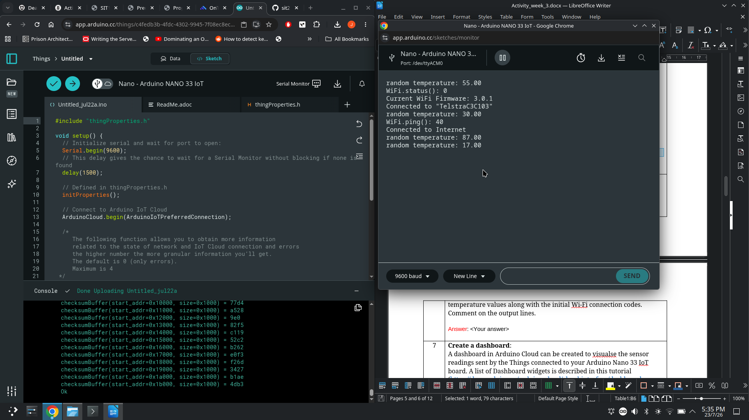
7 | Create a dashboard:  A dashboard in Arduino Cloud can be created to visualize the sensor readings sent by the Things connected to your Arduino Nano 33 IoT board. A list of Dashboard widgets is described in this tutorial (https://docs.arduino.cc/arduino-cloud/cloud-interface/dashboard-widgets ).  You can create a new dashboard from the Dashboards left menu items (https://app.arduino.cc/dashboards) where there are other menu items such as Devices and Things you have seen earlier. Creating a dashboard is simply choosing a dashboard widget, such as a Guage and link it to the Thing cloud variable you have created.  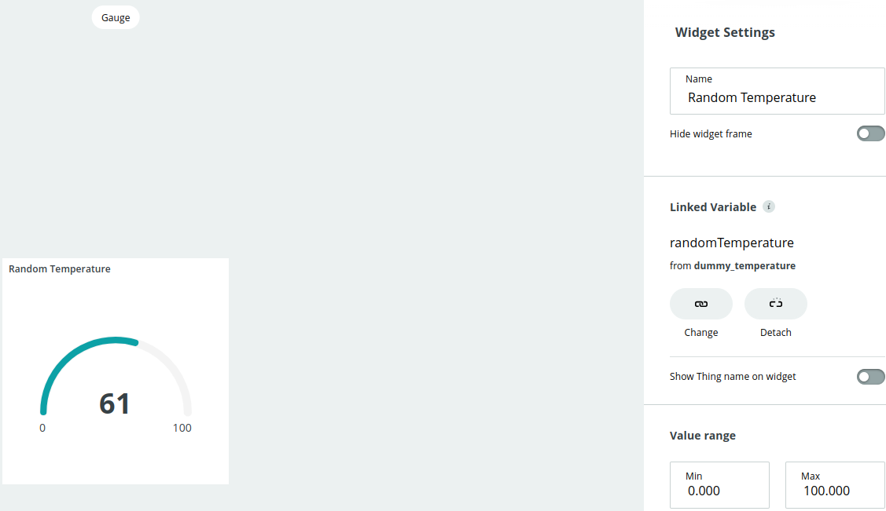  Once you click the Done button, you should look the Gauge widget is updating based on the value shown in the Arduino IDE serial monitor.  Question: Screenshot the output of the serial monitor with random temperature values and the dashboard output so the Gauge value can be found in the serial monitor output.  Answer:  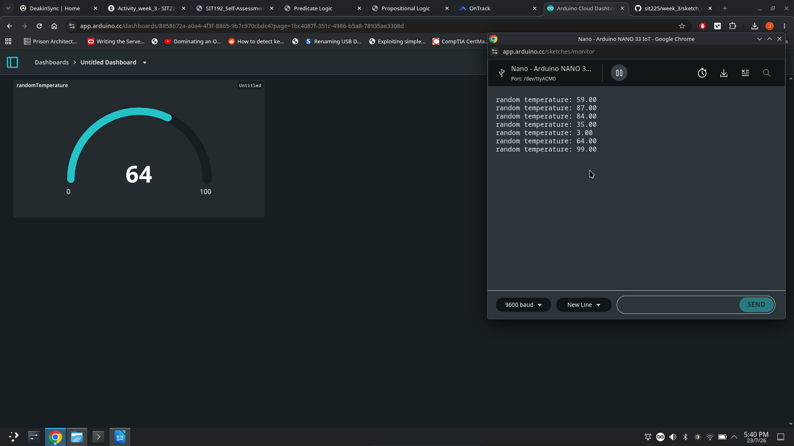
8 | Question: If you recall, there is a function initProperties() in thingProperties.h file where there is a single line -  A function onRandomTemperatureChange() exists (in sketch_iot_cloud.ino file) to respond to ON_CHANGE event. Can you explore what is the use of this function and when the ON_CHANGE event will trigger?  Answer:  This function is a call back function which is invoked when the value of randomTemperature has been changed. This can be set to periodic in the ‘things’ interface where the cloud variable was previously created. Further, other options such as read and write permissions can also be changed there. These control how devices are able to interact with the cloud variable. Moreover, the thingProperties.h file should never be manually edited in the editor as any changes will be automatically destroyed the next time that the cloud interface updates the file.

Activity 3.2: Arduino IoT Cloud with custom Python devices

You can connect anything to Arduino Cloud including a wide range of compatible Arduino boards such as Arduino Nano 33 IoT or a third-party device that speaks Python.

In this activity, you will connect a custom Python board to Arduino IoT Cloud and synchronise to another cloud variable, the one you created earlier, randomTemperature. This will enable you to receive data from Arduino board in your Python script.

Hardware Required
- Arduino Nano 33 IoT Board
- Wi-Fi hotspot (preferably your smartphone hotspot)
- USB cable

Software Required
Arduino programming environment (Arduino IDE)
Arduino IoT Cloud (https://app.arduino.cc)
Python 3

Steps
Step | Action
1 | Thing & Device Configuration:  Following the tutorial (https://docs.arduino.cc/arduino-cloud/guides/python ),  - Create a new Thing, by clicking on the "Create Thing" button.  - Click on the "Select Device" in the "Associated Devices" section of your Thing.  - Click on "Set Up New Device" and select the bottom category ("Manual Device"). Click continue in the next window and choose a name for your device.  - Finally, you will see a new Device ID and a Secret Key generate. You can download them as a PDF. Make sure to save it as you cannot access your Secret Key again.
2 | Create Variables:  Follow the same tutorial mentioned above and do the following steps:  - While in Thing configuration, click on "Add Variable" which will open a new window.  - Name your variable temperature and select it to be of a float type.  - Just below the variable name, there is a link ‘Sync with other Things’. Click the link and it will show a list of all the variables you have created so far in your Arduino Cloud account in all the devices.  - Select ‘randomTemperature’ variable from Arduino board and click the button ‘Synchronise Variables’.  - At this point the randomTemperature data sent from your Arduino Nano board will arrive in Arduino Cloud, then it will be written to Python device variable temperature. This value assignment triggers on_write event in the listening client and corresponding callback function is called.
3 | Create Python script:  Now you need to create a Python script to register to Arduino Cloud, register for a cloud variable called temperature and write a callback function for on_write event handling. You can write the code as below or download the code from here (https://github.com/deakin-deep-dreamer/sit225/blob/main/week_3/arduino_variable_sync.py ).  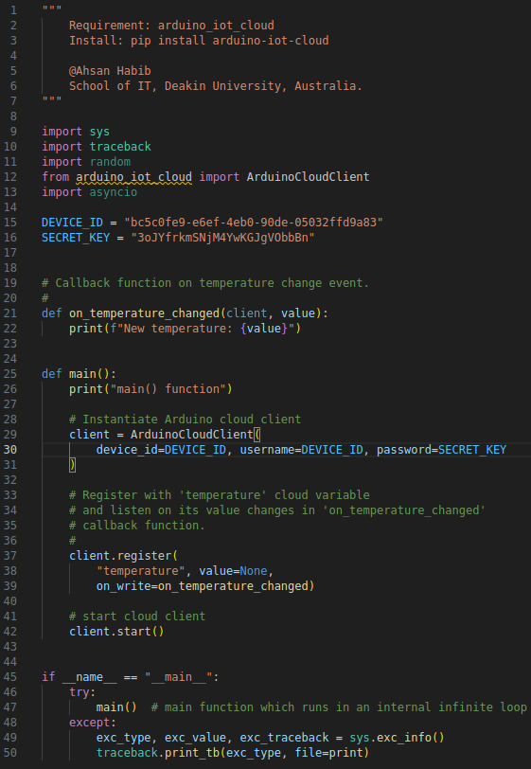  You should replace DEVICE_ID and SECRET_KEY as you were given in step 1-d above.  Question: Study the code and describe in your word how the statements match to the purpose mentioned in this step-3 above?  Answer: The above code attempts to connect to the arduino iot cloud using the device id and secret key that have been provided as part of the creation process. The client.register callback function declares that we are reading the temperature cloud variable and are showing the update to the python board on write. i.e. that is when the variable has been written to by the randomTemperature variable that it is linked to on arduino cloud. Naturally, the on_write argument has been passed the address of the on_temperature_changed function which will be the function that is called when the event occurs which prints the new temperature to the terminal window.
4 | Run Python script:  Run the python script from command line below -  $ python arduino_variable_sync.py  At this point, the command line output should show connecting to Arduino cloud and print new temperature values periodically.  Question: Screenshot the Arduino Cloud Dashboard gauge showing the Arduino side randomTemperature value and screenshot the Python command-line output showing similar values. Note that there might be some lag due to network connectivity. Explain your answer accordingly.  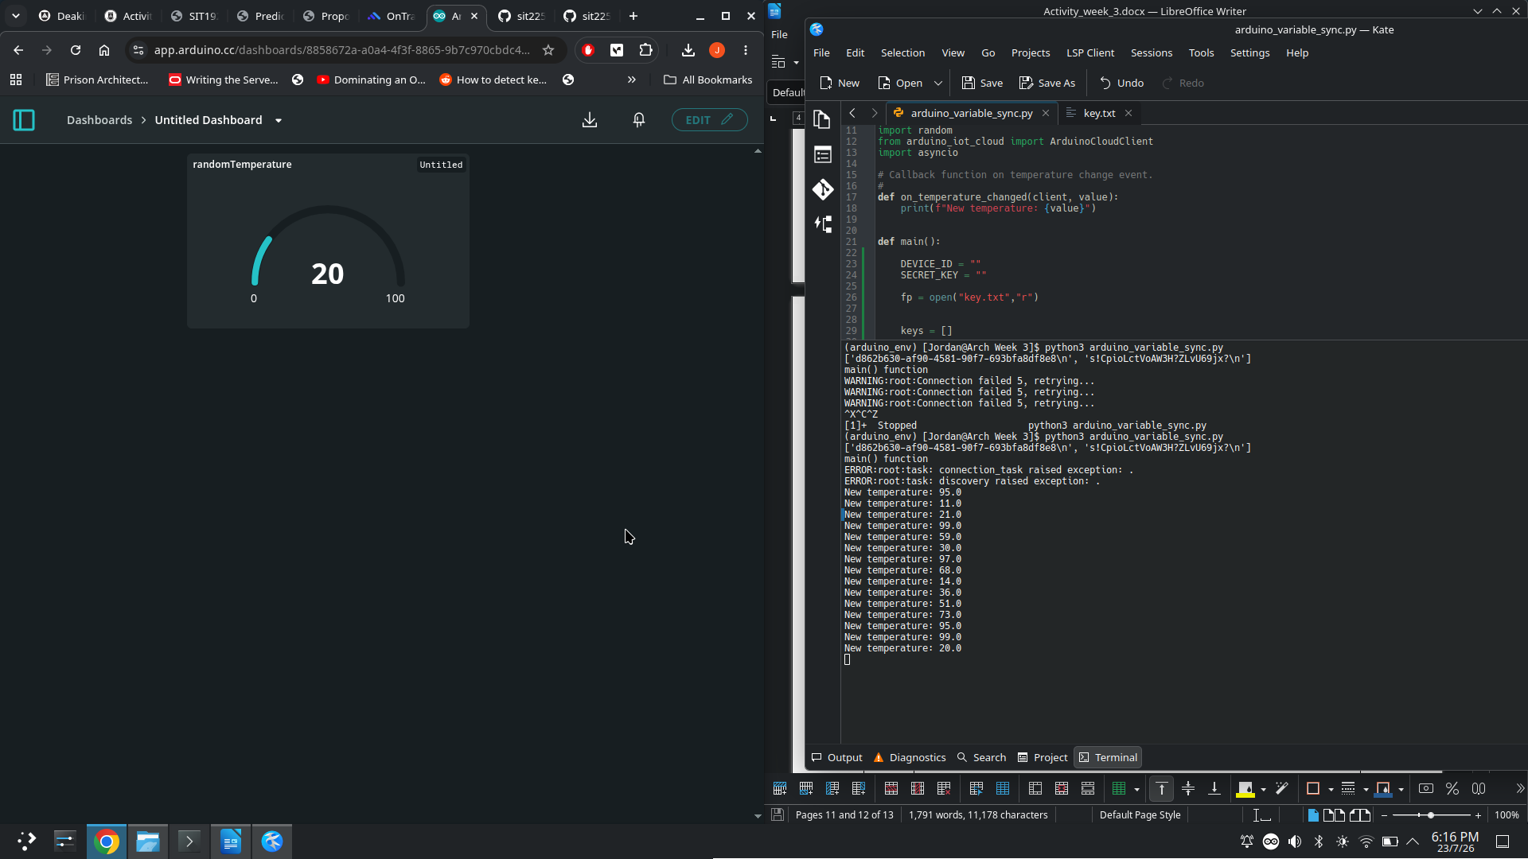  Answer:  The above screenshot shows both the dash board and the terminal interface running the python script. Both are currently in sync with each other. However, there is a slight delay between the two, this could be because of how the call back function is actuating and the time it takes for the callback function to execute may be quite slow.
5 | Question: Research how you can download data from Arduino IoT Cloud, say the randomTemperature variable if you continue the setup running for 10 minutes or so?  Answer:  Using the dashboard menu historic data from any variable linked to a dashboard can be downloaded. This is in the form of a csv file which can the be used for data analysis after the data has been appropriately prepared.
6 | Question: Discuss how you can save the data while you are receiving in Python script in a file? You can discuss in a group and come up with a solution.  Hint: An algorithm of appending data can be as below. Write Python code for the algorithm. You can put the code in the call-back function on_temperature_changed().  Algorithm: Append timestamp and data value to a file:  - Open a file in append mode  - Create a CSV string <timestamp>, <value> <NEWLINE>  - Call write function and pass CSV string, otherwise, call write_line function and pass the CSV string removing the ending <NEWLINE> (otherwise, a blank new line will be written to file).  - Call flash to push data to be written to file immediately.  - Close the file.  You can modify the algorithm to make it efficient, such as instead of opening/closing the file every time, move them to the beginning and end of the execution and keeping the CSV string formation and writing and flashing to file inside the callback function.  Answer: The above function is perfectly fine for use in creating a csv file even though it is conducting multiple file openings and closings. My personal solution would be to create an object that is representative of the csv format. The object would contain member variables such as timestamp,value. I would also have a method that returns the string which would be then passed to the write function that appends this information to the open file. However, in my implementation this would only occur once after all the data has been collected. These objects would merely be collected in a list.  Overview  1. Open the file in write mode  2. instantiate new csv object for each new reading passing the values to the  constructor  3. Append the object to a list (could be streamed direct to file instead of a list)  4. write list to file  5. close file

